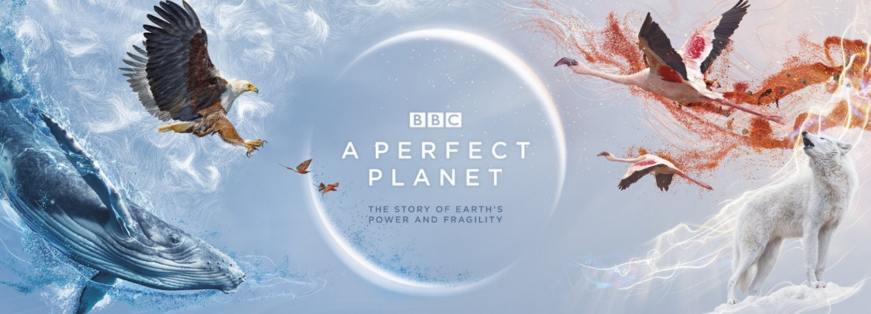

A Perfect Planet Episode 1

1. What is the focus of this fist episode? Volcanos
2. What natural forces allow life to flourish on Earth? Volcanos, The Sun, Weather systems, Ocean currents
3. How many active volcanos are there in the world today? Over 1500
4. The most active volcano is named what? And where can it be found? Kilauea in Hawaii
5. What is the liquid rock from a volcano called when it is below the Earth’s surface? Magma
6. What is the liquid rock from a volcano called when it is above the Earth’s surface? Lava
7. The active volcano in Tanzania is named what? Ol Doinyo Lengai
8. How many times has it erupted in the last 100 years? Erupted over 15 times
9. What is unique about Lake Natron? The water is so corrosive it can burn skin
10. What type of bird nests in Lake Natron? The Lesser Flamingo
11. What substance turns the Flamingo’s feathers pink (it also colours their eyes)? Algae
12. 80% of the Earth’s surface is the result of what? Magma bursting up from the Earth’s interior.
13. Which is the youngest island in the Galapagos Archipelago? Fernandina
14. How does the volcano help with the Iguanas eggs? The warmth helps incubate the eggs
15. Volcanic islands make up 5% of the planets land but are home to what percentage of its species? 20%
16. How have the Finches on Wolf island adapted to survive without traditional food available? They drink blood from other birds
17. Describe the features of an atoll? A ring shape of coral rock with a lagoon in the middle, they used to be volcanos worn down by erosion and lower sea levels
18. How might climate change impact Giant Tortoises at Aldabra? Sea levels rising, less vegetation to hide under, atolls lost.
19. The volcano in the middle of North America is called what? Yellowstone
20. What benefit does living near a Geyser bring River Otters at Yellowstone? Rivers flow all year round, allows fishing
21. The Kamchatka Peninsula lies along a fault line, and has the most geysers in the world, which animal takes advantage of the consequences of the heat the geysers provide? Bears
22. What is the name of the lake where the Bears fish for Salmon? Kurile Lake
23. A single ash cloud from a volcano can carry what? A billion tonnes of minerals
24. Which gas was first brought up by volcanos from deep within the Earth’s crust? Carbon Dioxide
25. Human beings release how much more Carbon Dioxide than all the volcanos on earth combined? 100 times more carbon dioxide